Arbitrary-sized

* Doesn’t mean random, we just don’t know ahead of time
* Whenever we have this kind of information, we will use self-reference in type comment

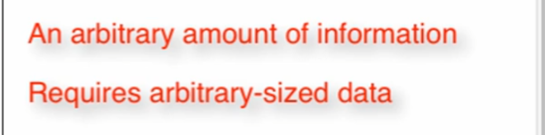

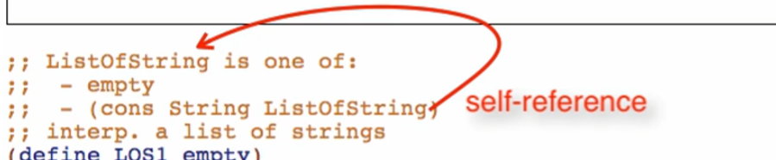

Well-formed Self-referential Data Definition

* **At least one base case**
  + Important so your function will not loop forever
* At least one self-reference case

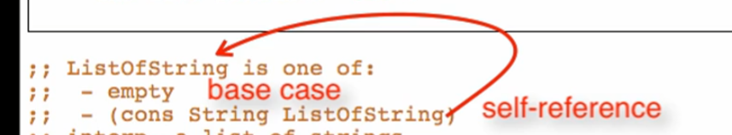

@design recipe:

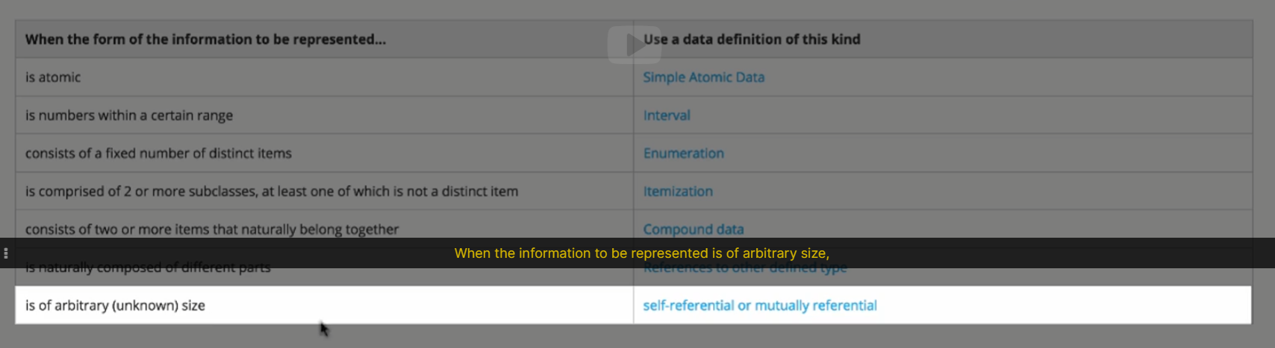

->

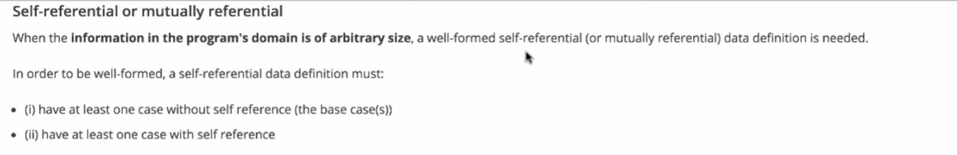

Note:

* Examples should include base case and referential case

Additional template rule:

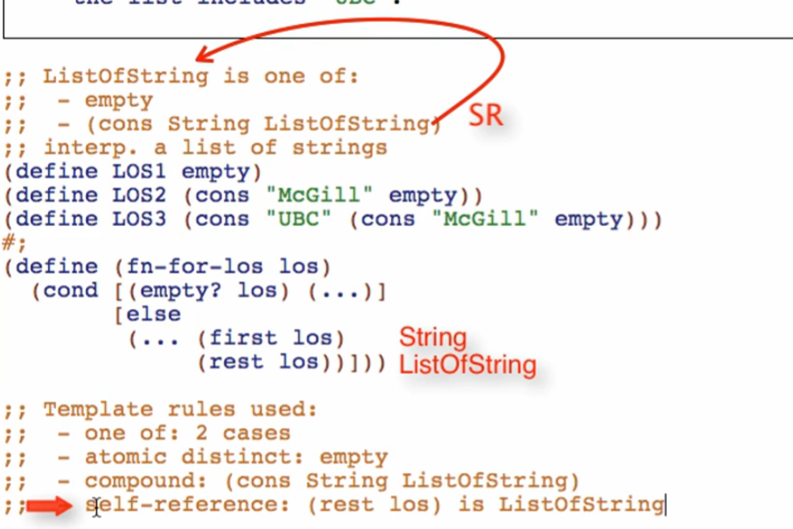

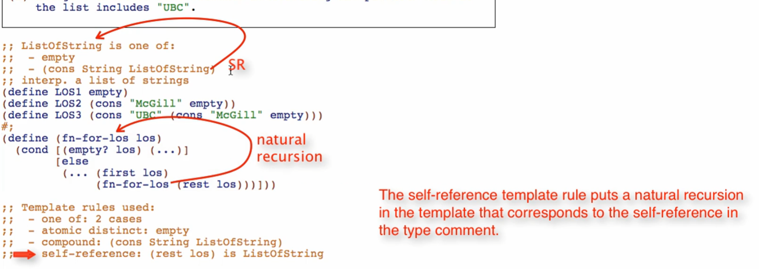

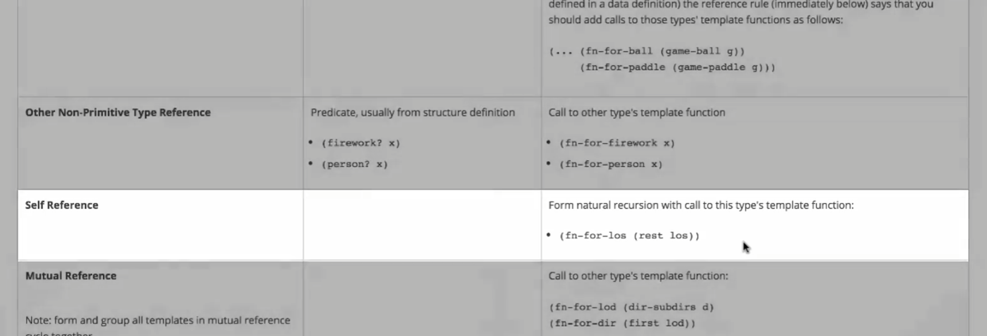

Check-expects

* Base case examples first
  + Simplest
  + Non-base case tend to rely on it
    - Base should be tested first before any other case
* Have one or more test which is at least 2 elements long

Function

* Rename the function on the definition and all natural recursions

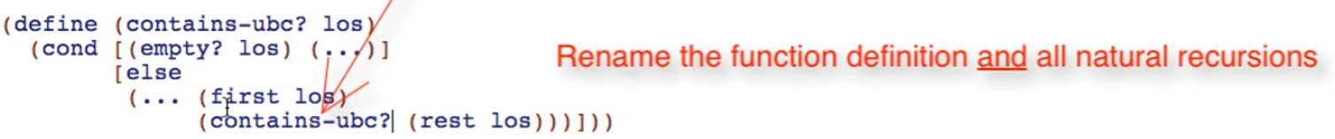

* TRUST THE NATURAL RECURSION
  + Make sure well formed self-referential type

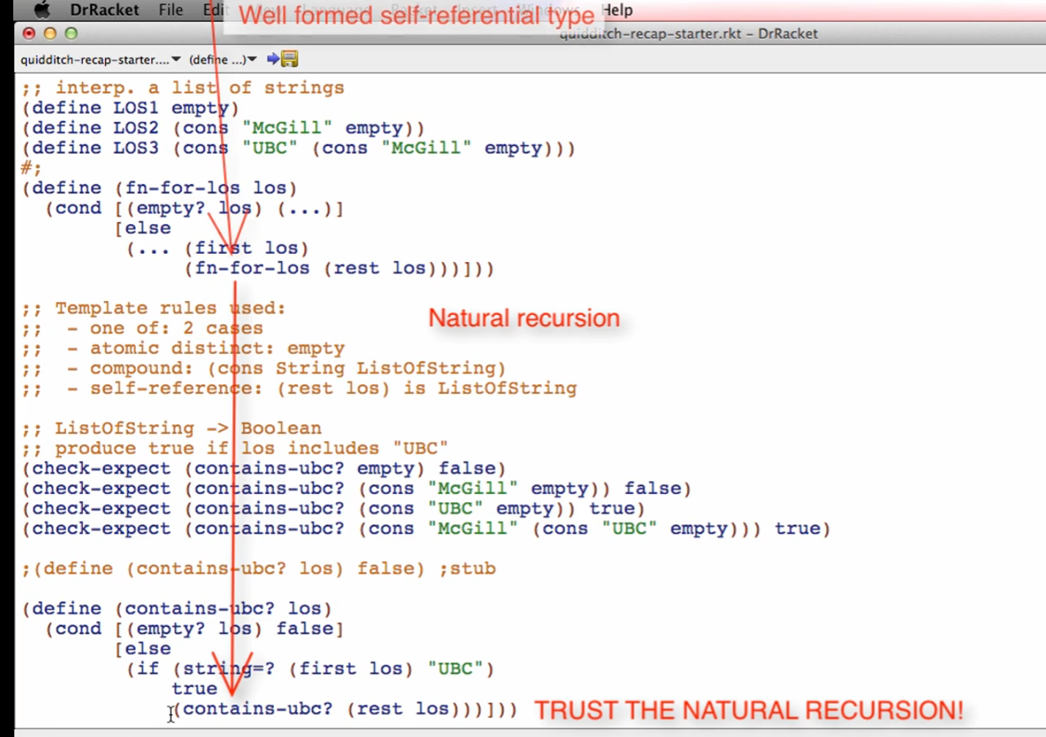

* Do not edit anything on the natural recursion statement!!

